Marketing Analysis Application using RAG powered Multi-Agent systems

## Introduction

For this year’s problem statement, we need to showcase pathway’s RAG architecture and how it can be used for fast data retrieval. The most commonly available platform for fast flowing data is social media. Hence the best place to showcase improvements in fast retrieval pipelines would be to create an application which allows large corporations to see product perception on social media platforms and internet articles.

This will allow platforms to make more informed decisions about improving their product. Geolocation data will also be useful for companies to analyze region-wise sentiment analysis.

## Basic Structure

This flowchart gives a broad overview of what this platform aims to achieve. We first send a query depending on the product whose analysis we require. Pathway’s RAG retrieval pipeline would then be used to collect data from various social media platforms as well as other data which the company will feed in.

The “other data” (as given in the flowchart) will be specific data about the product we are searching about. (Specifications, advantages, disadvantages, etc.).

This will give us some relevant documents which will be processed in a multi-agent sentiment analysis system. Each agent will analyze the corpus of data for different emotions. One agent will also generate a concise summary of the text. Similar work has already been done for financial advice based on financial data and social media analysis (<https://medium.com/@batuhansenerr/ai-powered-financial-analysis-multi-agent-systems-transform-data-into-insights-d94e4867d75d>)

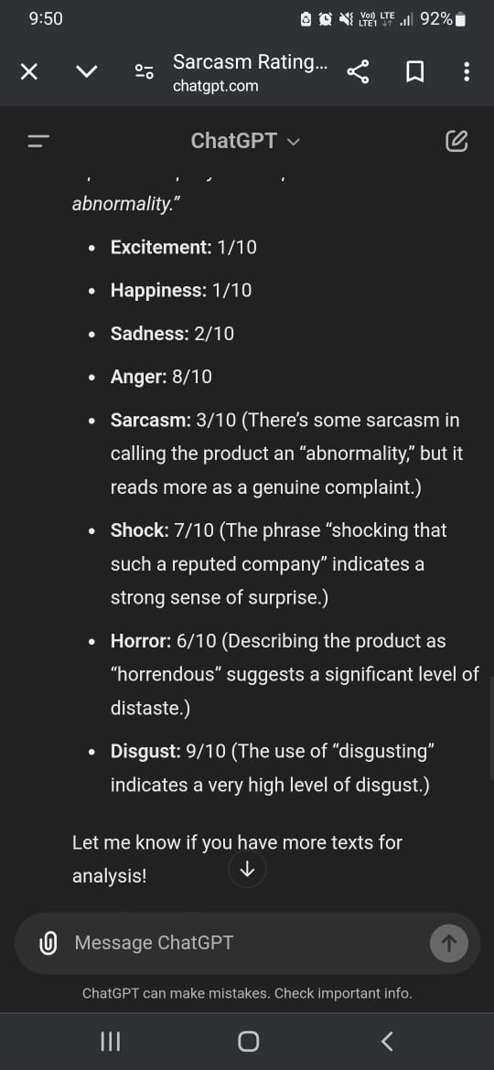

Asking ChatGPT to rank a piece of text based on different

emotions. This can be improved using a multi-agent approach

For internet articles, we can get live web data using the existing python framework EXA (<https://exa.ai>). This API uses RAG on the internet to give us a list of relevant articles. These can be used to conduct market research on articles written about a particular product.

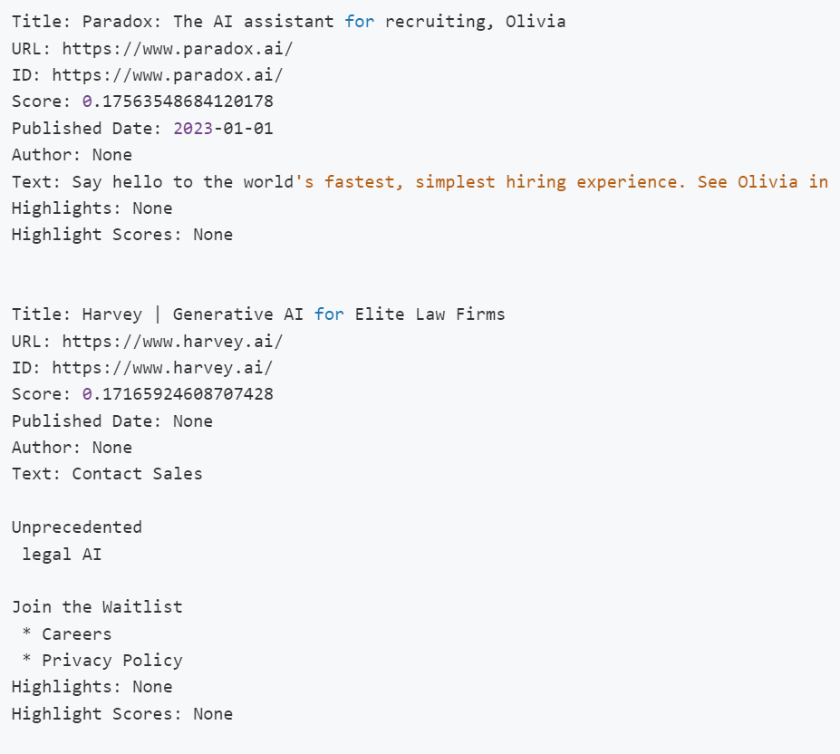

Using EXA to get relevant articles from the web.

After we process our data and rate it for different emotions, we can combine this data to give an overall sentiment analysis of our product. The summary generator will also produce a report which will give an overview of the customer feedback on a particular product.

Exa search is very useful as it has pre-built wrappers for OpenAI and CrewAI and can hence be integrated easily to any solution.

# Region-wise sentiment analysis using Pathway

Pathway allows region wise social-media analysis. It collects data from twitter using the tweepy API (<https://www.tweepy.org>) which is available for free. It then performs RAG on this corpus of data, which gives us relevant information based on a particular product.

The example application on the Pathway website also describes an iterative approach for filtering out incorrect geolocation data. For this their algorithm uses the number of retweets from other users near the location of each user. If the number of retweets are less than a certain threshold, we flag the location of that user as potentially incorrect.

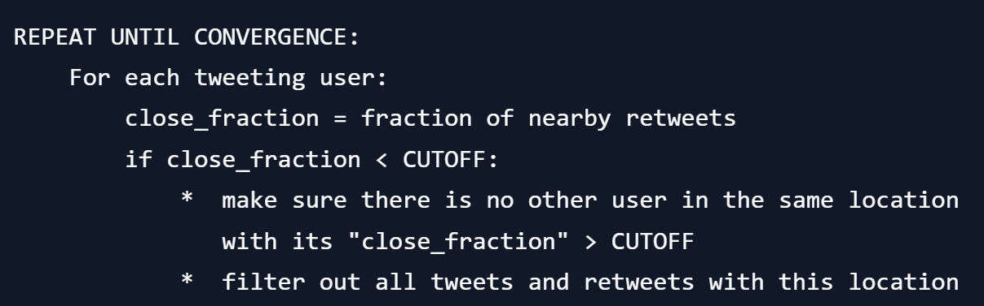

Summary of the location-filtering

algorithm in pseudocode

Result with OpenStreetMap

This can be used by companies to see how each region perceives their product.

# Multi-agent-based decision making

Once we get the final sentiment analysis, we can also use a multi-agent system to generate advice for a particular firm. These agents will look at the problems from different angles (financial, technical, etc.). This data will then be provided to the company so that it can make more informed decisions.

# Summary

Our platform aims to do the following:

* Use pathway’s RAG pipeline to get useful insights from a large corpus of social media data.
* Analyze sentiments and other aspects using a multi-agent system.
* Generate sentiment analysis of a product, along with a summary of features and drawbacks of the product
* Final Advice generation

# Useful links

<https://pathway.com/developers/templates/twitter>

<https://github.com/pathwaycom/pathway/tree/main/examples/projects/twitter>

<https://exa.ai>

<https://medium.com/@batuhansenerr/ai-powered-financial-analysis-multi-agent-systems-transform-data-into-insights-d94e4867d75d>

<https://www.tweepy.org>

# 